51.2.2.18 Simplified 7.1.1

You can get to this function also via 51.2.2.22.
- Double left mouse on SO.
- By using bottom Due Date.

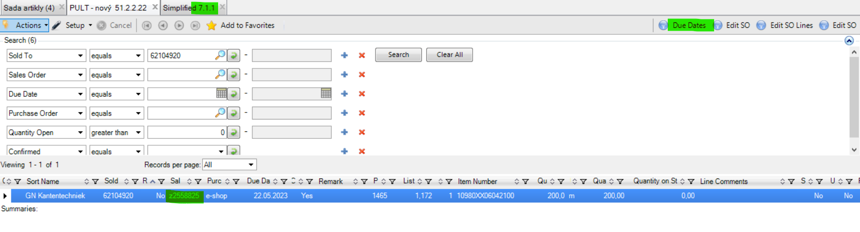

51.2.2.18 is a direct function to get here and you can immediatelly change here Due Date, Purchaser Order, Remark or you can write down a comment on a header level.

Sales Order – just put sales order number
+ Next
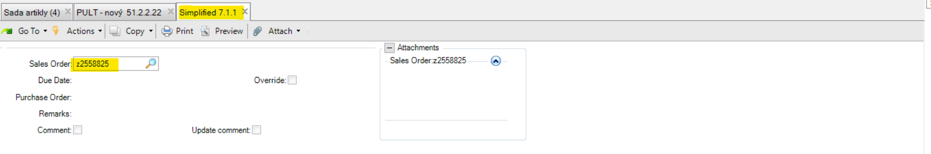

Now you can fill thes fields as you need.
Comment – clicked box = there already exists some text / unclicked box = there is no text
Update Comment – if you need to add a comment = click the box
+ 1x Next / + 1x Back / + 1x Next
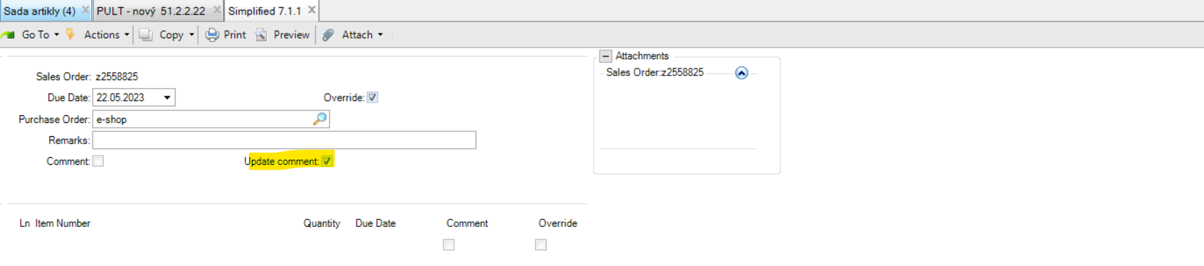
Now you can write a comment what you need.
You can use this way when adding text on the invoices, e.g.
+ Next
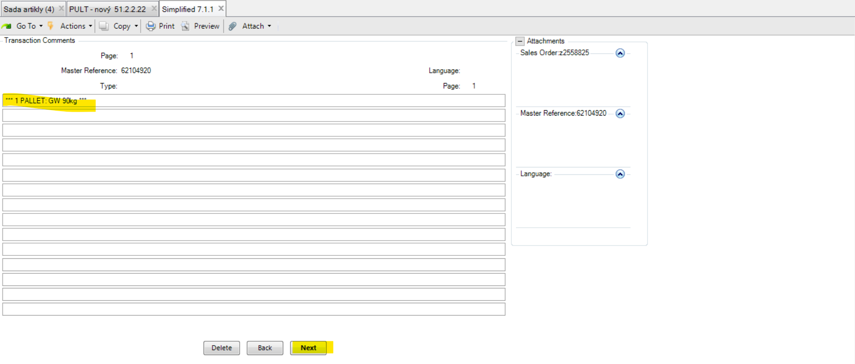
Print on Quote – clicked = we don´t use Quotes in QAD, so you can click or leave it blank.
Print on Sales Order - clicked = visible on Order Confirmation (customer sees it on OC)
Print on Invoice – clicked = visible on invoice (customer sees it on OC)
Prin On Packing List – clicked = visible on PDL and delivery note (stockmen see it on PDL/DL)
+ 1x Next / 1x back

Kinldy note that only the first line is visible on all above documents. There is limited space for text.

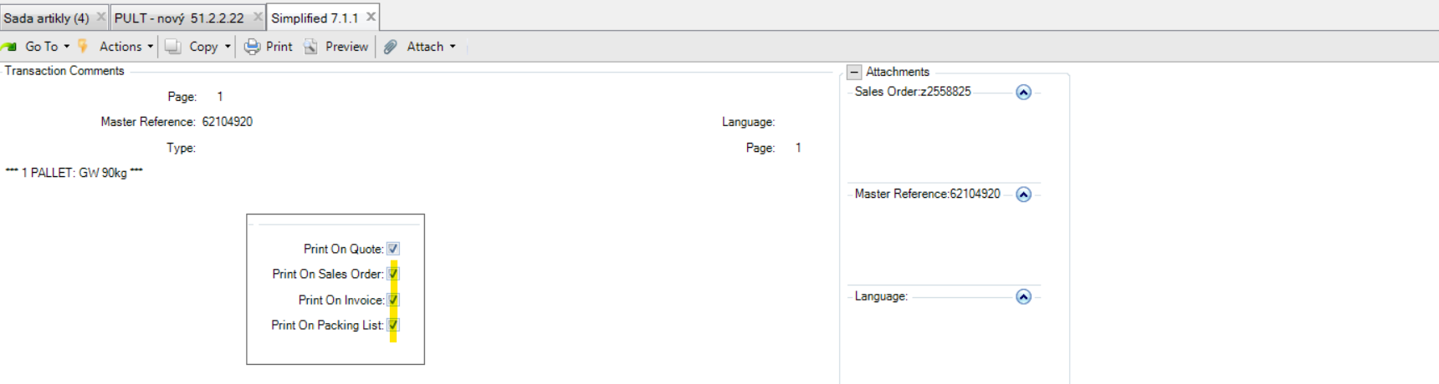

Close comment maintenance – YES, if you want to confirm it.

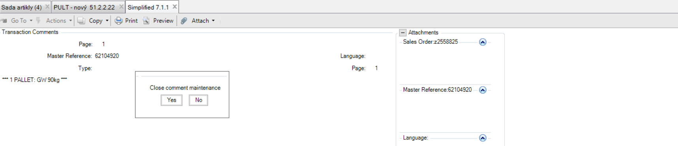

Then you are back at the first screen and that´s it.

Comment – is clicked now. You can directly see it when using this function. Means there is a text.

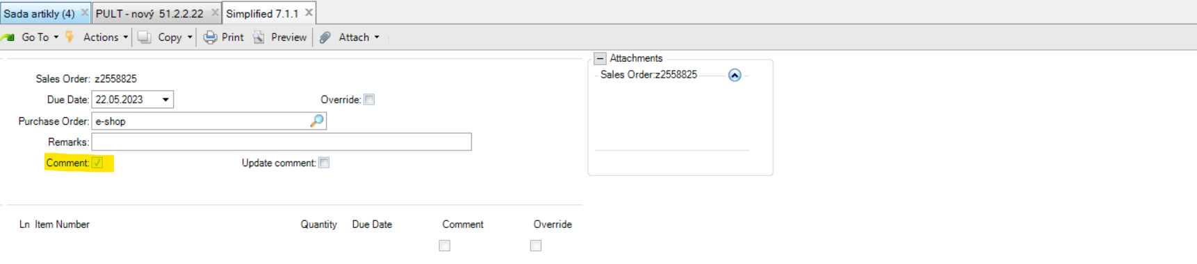

If you need to change or delete a text.

Update Comment – click the box
+ 1x Next / 1x Back / 1x Next

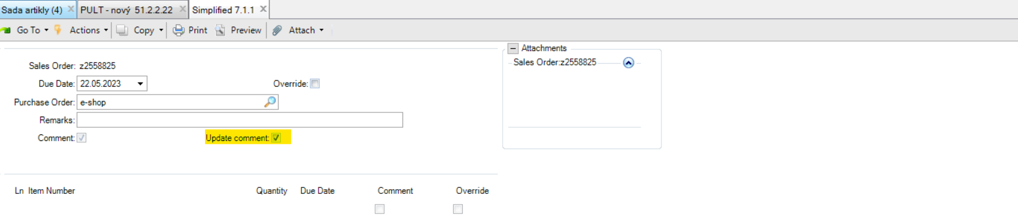

Delete – you can delete the text from here if there is already any and you don´t need it.
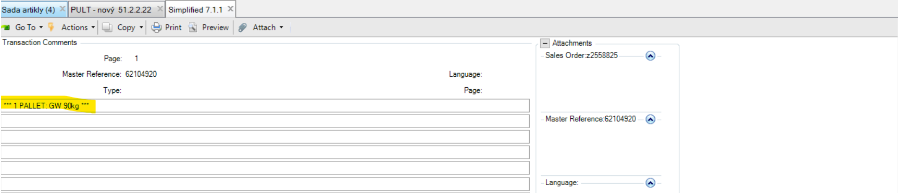

Please confirm delete – Yes
1x Back
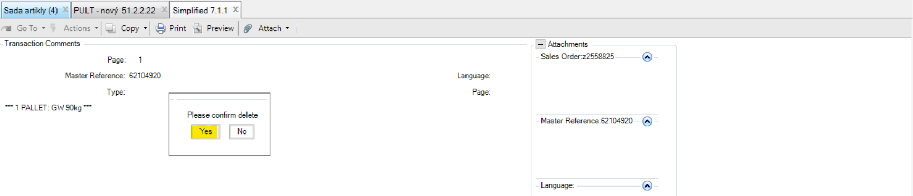
Close comment maintenance – YES, if you want to confirm it.
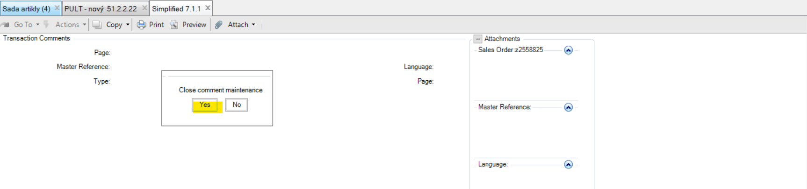

Then you are back at the first screen and that´s it.
You can see here now that Comment is blank = no text.
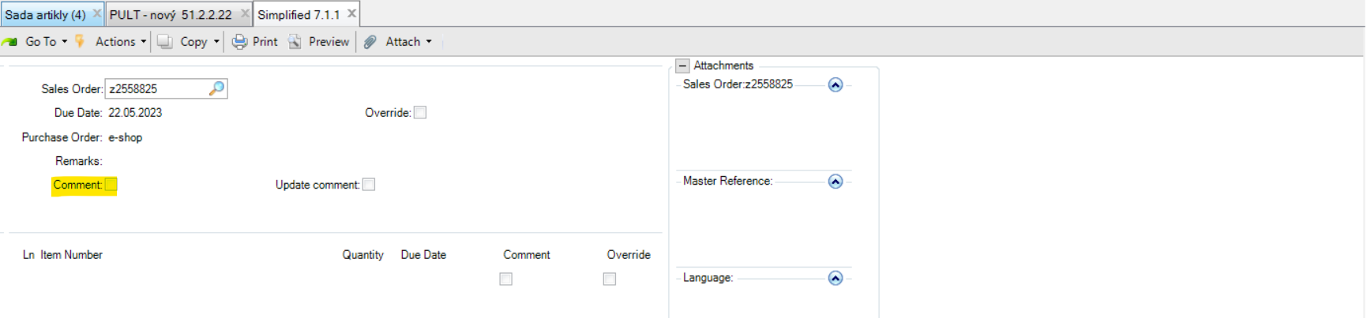

Due Date – set a term
Override – must be clicked if you want to set Due Date on all items in your sales order (on header level)
+ 1x Next / 1x Back (to confim)
